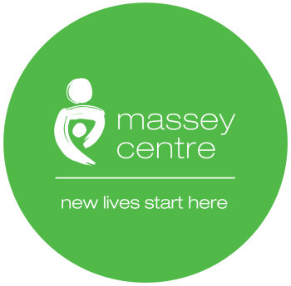

Massey Centre
Early Learning Centre COVID-19 Hand Hygiene and Respiratory Etiquette

Name of Author: ELC Management Team

Ratified by: Senior Management Team

Document Version No: 01 2020

Latest Re-issue Date:

Review Date:

Date Approved by Senior Management Team: July 6, 2020

Amendment Record
Page number | Paragraph number | Change | Date of Change

Table of Contents

- Introduction 3
- Policy 3
- Procedures 3
- Acknowledgement and Agreement 4

- Introduction

  - The Massey Centre’s Early Learning Centre (ELC) is committed to developing an enhanced practice for Hand hygiene and Respiratory etiquette for children, child care staff and essential visitors who enter the Early Learning Centre (ELC) Building.

- Policy

  - The Centre will maintain safe and effective hand hygiene and respiratory etiquette for all persons entering the ELC Building. All staff and children will practice proper hand hygiene (e.g., before and after eating, after using the bathroom or diapering, after covering a cough or sneeze, after wiping nose, transitions from indoor to outdoor, or outdoor to indoor, and before and after PPE use, etc.,). ELC staff shall also supervise and/or assisting children with hand hygiene.

- Procedures

  - Proper hand hygiene and respiratory etiquette is an infection control measure for all staff, children, parents/guardians and essential visitors to use to stop the spread of COVID 19.

  - Staff and children will use proper hand washing techniques using soap and water or with hand sanitizer (70-90% alcohol concentration) if a sink is not accessible.

  - Staff are to monitor and assist children when using hand sanitizers. Staff and children will be trained to avoid touching their face, nose and mouth without washing hands first.

  - If sneezing or coughing, use universal health precautions to sneeze or cough into a tissue or lacking a tissue, sneeze into your elbow sleeve. Throw out the tissue immediately into a closed, hands free, lined garbage bin and wash hands immediately.

  - Children over two years can safely use hand sanitizer with staff supervision, however children 2 years and under will have their hands washed with soap and water.

  - When to wash hands:
Whenever necessary wash hands when needed included but not limited to washing:
- Before and after a meal
- During handling food or distribution of food
- After using the bathroom
- During diaper/toileting routines
- After wiping a child’s nose
- After sneezing or coughing
- Prior to wearing or donning a face mask and gloves
- Before and after your shift ends or begins
- Distributing material or equipment supplies or using equipment and supplies
3.7 The ELC shall monitor hand hygiene supplies to ensure adequate amounts of liquid
soap, paper towel, hand sanitizer, tissues, and waste receptacles lined

- Acknowledgment and Agreement

I, acknowledge that I have read and understand the Hand Hygiene and Respiratory etiquette of Massey Centre. I agree to adhere to this policy in whole. I understand that if I violate the rules set forth in this policy, I may face disciplinary actions, up to and including termination of employment.

Full Name
Please Print
Signature
Date
MM/DD/YYYY

