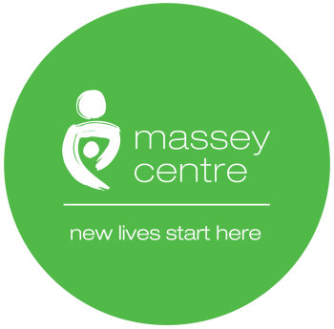

Massey Centre
Early Learning Centre Requirements for the Use of Toys Equipment
and other Materials During COVID 19 Policy and Procedure

Name of Author: ELC Management Team
Ratified by: Senior Management Team
Document Version No: 01 2020
Latest Re-issue Date:
Review Date:
Date Approved by Senior Management Team: July 6, 2020

Amendment Record
Page number | Paragraph number | Change | Date of Change

Table of Contents

- Introduction 3
- Policy 3
- Procedures 3
- Acknowledgement and Agreement 4

- Introduction

  - Massey Centre’s Early Learning Centre (ELC) will ensure that the children’s toys, equipment and other materials are appropriate and safe during the COVID-19 Pandemic.

- Policy

  - The ELC staff will ensure that the toys, equipment and other materials for children are suitable for cleaning and disinfection. Toronto Public Health Guidance will inform our cleaning and disinfection practices.

- Procedures

  - Toys and equipment will be made out of material that can be cleaned and disinfected.

  - All plush/cloth toys not permitted.

  - Sensory group play and activities will be suspended

  - Mouthed toys will be separated from other toys, cleaned and disinfected immediately after children have used it.

  - Toys are sterilized in a dedicated mechanical dishwasher which is exclusively used for toys sterilization and is set at more than 82 degrees Celsius.

  - Toys and art material will be provided in an individualized labeled bin for each child to prevent sharing.

  - Toys and large indoor play structures must be cleaned and disinfected between cohorts with wipes.

  - Playroom toys and large play structures are kept within the cohort and not allowed to be shared by other cohorts.

  - Outdoor play structures will be used by one cohort at a time.

  - If items are too big for the sterilizer, then staff are to clean the toys or equipment by one of the following methods:

- Using disinfecting wipes or other cleaning products. Toy that are cleaned by disinfecting spray or wipes need to have enough contact time and to allow for air drying; or
- The two sinks method if washing and rising are done in the first sink. Please note that washed toys must not be left to air dry in the food preparation, toileting or bathroom areas.
- Acknowledgment and Agreement

I, , acknowledge that I have read and understand the ELC Requirements for Use of Toys and Equipment during COVID –19 Policy and Procedures of Massey Centre. I agree to adhere to this policy in whole. I understand that if I violate the rules set forth in this policy, I may face disciplinary actions, up to and including termination of employment.

Full Name
Please Print
Signature
Date
MM/DD/YYYY

